**APPLICATION DEVELOPMENT FOR FINDING FLATMATES**

**WEB PRESENCE FOR THE APP:**



**How do you define online presence?**

**Online presence is, and isn’t, exactly what you may think. You can very well exist online, but that doesn’t equate to having a presence. Your presence is a deeper layer that paints the full picture of your business, according to:**

* **You: The actions you take and the content you produce.**
* **The internet: Where you stand with regard to search engine and social media algorithms.**
* **The public: How people perceive your business online, what they say about you, how they engage with you.**

**So while an online *existence* may get you on the map, an**[**online *presence***](https://localiq.com/blog/reasons-your-web-presence-more-important-now/)**is tied to your visibility, credibility, and reputation.**

**Without a strong online presence, you really don’t have one at all. It’s all or nothing in the noisy world of cyberspace.**

**Why you need a strong online presence?**

**The more ways you can place your business in front of your target audience *with quality experiences,* the more opportunities you have to build brand awareness and improve your reputation. But there are other ways a strong online presence benefits your business.**

* + **Get discovered:**[**97%**](https://www.comparehare.co.uk/97-of-consumers-search-for-local-businesses/)**of consumers search online for local products and services. A strong online presence makes it easy for ideal customers who don’t yet know you exist to discover you, both when they are and are not searching for what you have to offer.**
  + **Be seen as a legitimate business:**[**83%**](https://www.thinkwithgoogle.com/consumer-insights/consumer-trends/store-visit-after-online-research-data/)**visit a store based on the information they found online. Consumers rely on multiple sources of information before making a purchase. If you don’t provide information about your business across all of these sources, you’ll be dismissed—by consumers and search engines alike.**
  + **Market your business 24/7: If you have a strong online presence set up, people can discover, learn about, engage with, and reach out to you whenever is best for them, no matter where they are in the buyer journey or what device they are using.**
  + **Save money: Digital marketing platforms all come with data to tell you what’s working and what’s not, so you can allocate your budget accordingly.**
  + **Get more conversions: It takes an average of**[**seven**](https://www.thebalancesmb.com/how-to-use-the-rule-of-7-to-radically-grow-your-business-4037683)**encounters with a business before a lead becomes a customer. Being prominent on multiple channels creates opportunities for those engagements to happen more quickly.**
  + **Earn Google’s trust: Google takes more than just your website into account when ranking. It actually looks at your assets across the web and how consistent they are.**
  + **Perfect your buyer journey:**[**63%**](https://sleeknote.com/blog/online-shopping-statistics#5)**of shopping journeys start online. With a strong online presence, you can be available to consumers at different points in their journey toward customer ship, which includes multiple devices.**

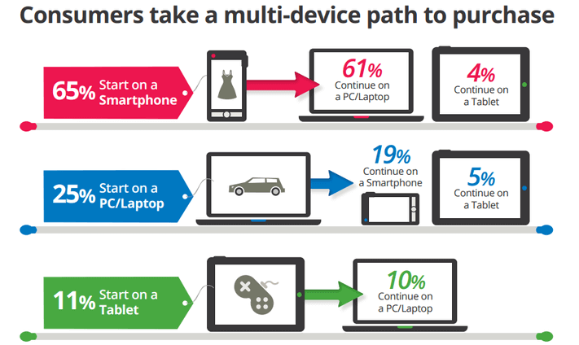

**How to increase your online presence with your website:**

**No matter how someone finds out about your business—whether through social media, an ad, a listing, direct mail, a friend, or even seeing it in their travels—their first inclination is to go to your website. Going into the business or calling is far less appealing than browsing your site on their own terms and gathering the information they want, quickly. Which is why**[**56%**](https://www.verisign.com/assets/Research-small-business-september2013.pdf?inc=www.verisigninc.com)**of consumers won’t consider a business without a website.**

***56% of consumers won’t consider a business without a website.***

**And that’s a stat from 2017, so the percentage has most likely grown and been further accelerated by the**[**pandemic**](https://www.wordstream.com/blog/ws/2020/10/27/post-pandemic-marketing-strategies)**.**

**So with that being said, here’s how to use your website for an optimal online presence:**

**Get a modern, attractive site**

**Consumers have high expectations these days—to the point where if you don’t have a good website, you’re almost better off not having one at all. In fact,**[**75%**](https://www.kinesisinc.com/the-truth-about-web-design/#:~:text=According%20to%20web%20credibility%20research,based%20on%20their%20website's%20design.)**of consumers have admitted to judging a company’s credibility based on their website design.**

**Having a lead-generating website that looks and functions exactly the way you want it to without losing hours of your time or hairs on your head is worth every penny.**

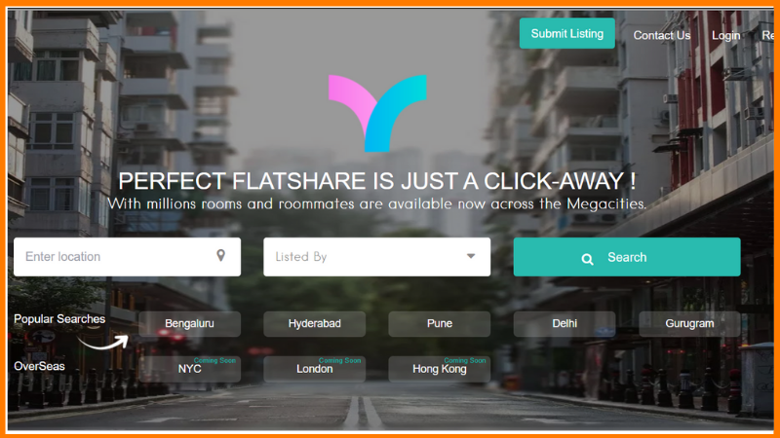

**Perform SEO with the latest updates in mind**

**Did you know that only**[**49%**](https://themanifest.com/sem/small-business-seo-statistics)**of small businesses invest in SEO? Or that only**[**18%**](https://themanifest.com/sem/small-business-seo-statistics)**of small businesses do not plan to ever pursue targeted SEO efforts like**[**link building**](https://www.wordstream.com/blog/ws/2020/12/10/link-building-secrets)**,**[**content creation**](https://www.wordstream.com/blog/ws/2012/01/17/seo-content-beginners-guide)**, or**[**keyword research**](https://www.wordstream.com/blog/ws/2017/08/09/easy-keyword-research-guide)**?**

**SEO is a free way to**[**get on the first page of Google**](https://www.wordstream.com/blog/ws/2020/08/19/get-on-first-page-google)**—the hallmark of online presence.**

**It takes time, but when done right, it is the gift that just keeps on giving.**

**Here’s how to use**[**SEO**](https://www.wordstream.com/blog/ws/2015/04/30/seo-basics)**to increase your online presence:**

* **Follow the tried-and-true best practices like creating quality, keyword-targeted content, optimizing images, and building links.**
* **Improve your**[**Core Web Vitals**](https://www.wordstream.com/blog/ws/2021/04/02/improve-core-web-vitals)**to align with the**[**page experience update**](https://www.wordstream.com/blog/ws/2020/10/19/core-web-vitals-google-page-experience-update)**.**
* **Stay on top of mobile errors. All sites on the web are now indexed by**[**mobile-first indexing**](https://www.wordstream.com/blog/ws/2021/04/15/mobile-first-indexing)**.**
* **Use schema mark-up so that rich snippets can appear below your site title in the SERP, like ratings or even your main navigation pages.**
* **Prioritize**[**local SEO**](https://www.wordstream.com/blog/ws/2018/10/12/local-seo)**. The pandemic has strengthened consumer support for local businesses, which will continue**[**post-COVID**](https://www.wordstream.com/blog/ws/2021/05/12/inspiring-post-covid-marketing-ideas)**.**

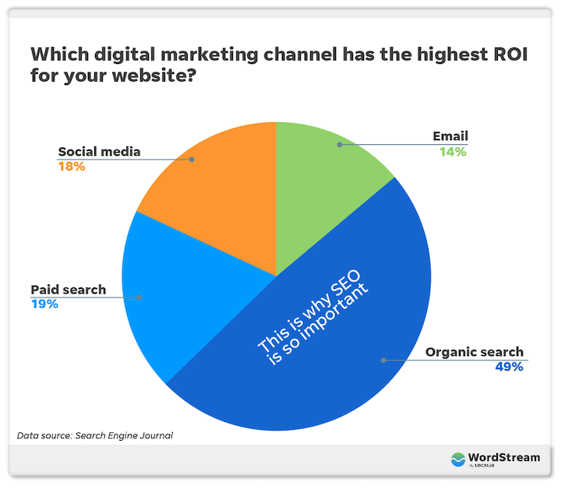

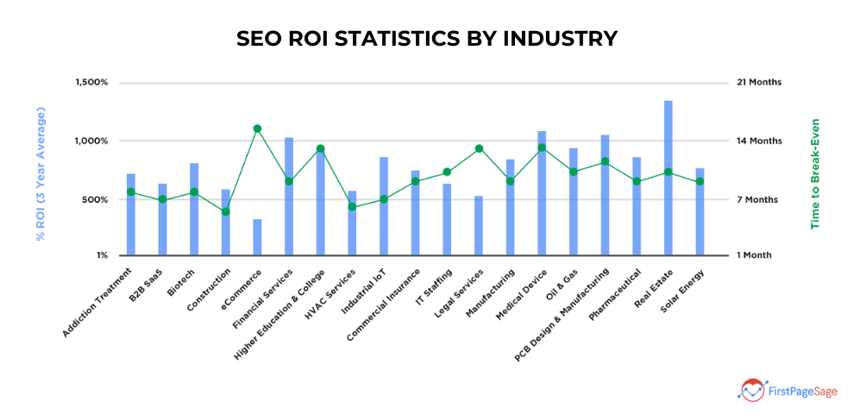

**Target more keywords with a business blog**

**The core pages of your website (homepage, about, pricing, products/services, contact) are relatively limited in terms of optimizing for keywords other than your service and location. You don’t have much text to work with and the goal is to distill the information down to the essentials visitors are looking for.**

**With a business blog, each post you publish can dive deep into a relevant keyword and be individually optimized to**[**rank for that keyword**](https://www.wordstream.com/blog/ws/2012/11/14/how-to-rank-for-a-keyword)**, allowing you the opportunity to appear in search results for tons of searches your target customers are performing at various stages in their journey. More first-page appearances doesn’t just mean**[**stronger web presence**](https://localiq.com/blog/reasons-your-web-presence-more-important-now/)**; it also equates to**[**more traffic**](https://www.wordstream.com/blog/ws/2014/08/14/increase-traffic-to-my-website)**to your conversion-optimized site and greater credibility.**

**In fact, businesses that publish blogs four times a week get**[**3.5x**](https://techblogbuilder.com/2020/01/15/how-often-to-blog-tech-website/)**more traffic and 4.5x more leads than businesses that only blog once a week.**

**Plus, this is where you can demonstrate your expertise and let your**[**brand personality**](https://www.wordstream.com/blog/ws/2021/03/31/brand-personality-messaging)**shine through—both of which play into the reputation component of your online presence.**

**When blogging for online presence, make sure to:**

* **Target one keyword (or keyword theme) per post and include it in your title, headings, image file names, alt text, and Meta description.**
* **Target question keywords with H2s to increase your chances of showing up in “People also ask.”**
* **Use numbered and bulleted lists where appropriate to be**[**featured Snippet**](https://www.wordstream.com/blog/ws/2015/10/13/google-answer-box)**-friendly.**
* **Promote your posts using social media and email.**

**How to increase online presence with social media:**

**Using social media to increase your online presence is a no-brainer, as its vast user bases and sharing capabilities make it an amplification tool. We also know that**[**social signals can impact your SEO**](https://www.wordstream.com/blog/ws/2022/10/20/social-signals-for-seo)**.**

**Plus, according to**[**Sprout Social**](https://sproutsocial.com/insights/social-media-statistics/)**, after following a brand on social media,**[**91%**](https://sproutsocial.com/insights/social-media-statistics/)**of consumers will visit its website, 89% will buy from the brand, and 85% will recommend the brand to a family or friend.**

**Here’s how to improve your social media presence:**

**Limit the number of platforms to only what you can handle**

**Online presence is about quality, not quantity. Choose the platforms that your audience is using, and limit the number you choose based on your bandwidth. Having just one or two accounts with solid engagement is better than having several accounts with weak activity.**

**Platforms to consider include:**

* **Facebook**
* **Instagram**
* **LinkedIn**
* **Twitter**
* **YouTube**
* **Pinterest**
* **Snapchat**

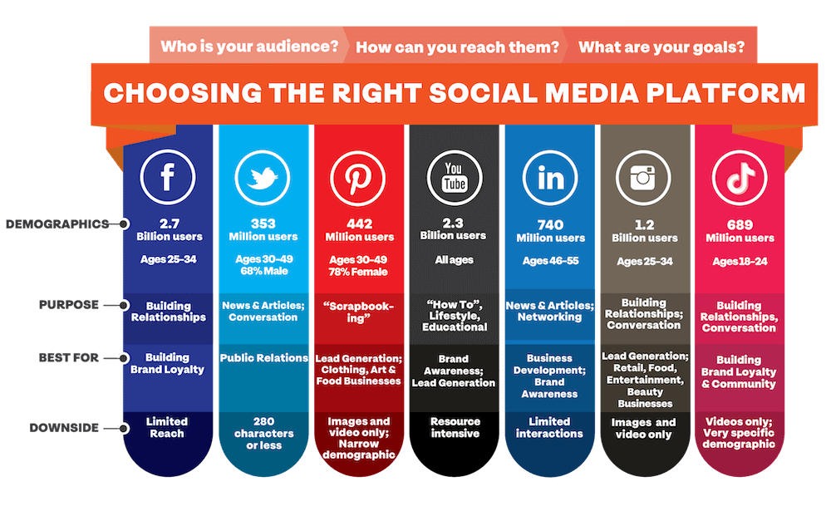

**Think audience, not followers**

**Your online presence doesn’t improve with more followers. Rather, your following improves with a stronger presence. So work on cultivating a quality, niche audience of individuals who are interested in and can benefit from what you have to offer. This will translate into more likes and comments with your posts and more user-generated content. And if you didn’t already know, marketing campaigns with user-generated content result in**[**29% higher conversions**](http://www.adweek.com/socialtimes/why-consumers-share-user-generated-content-infographic/639636)**than campaigns or without it.**

**It’s better to have fewer followers with a vibrant page than to have lots of followers and not much value to offer.**

**Post with emotion for share ability**

**Quality posts that get engagement are important if you want social algorithms to display your posts in users’ feeds. But quality isn’t really enough. You want your followers to feel something when they consume your content—so much so, that they feel compelled to share it with others. Use**[**emotional words and phrases**](https://www.wordstream.com/blog/ws/2021/01/13/best-words-and-phrases-for-marketing)**in your captions. Add emoji’s. Use compelling stats and evocative images.**

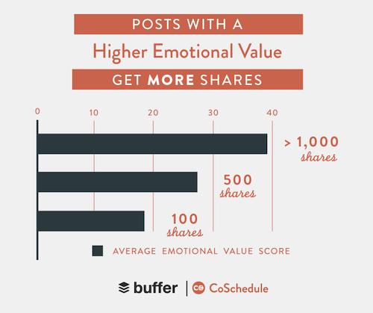

**Perform social media SEO**

**Facebook receives over**[**2 billion**](https://techcrunch.com/2016/07/27/facebook-will-make-you-talk/)**searches per day. And in 2020, Instagram announced that it now supports general keyword searches (as opposed to just accounts, hashtags, and people). So just like with your website, you should include**[**popular keywords**](https://www.wordstream.com/popular-keywords/business-keywords)**in your profiles and posts. You can use many of the same keywords as you do with your site, but perhaps with a bias toward idea-oriented and lighter-hearted queries. Social media platforms are more of the browsing and inspirational types. But it all depends on your business.**

**How to improve your online presence with listings:**

**With thousands of online directories out there, creating listings for your business can help you show up in more places online. In addition, links to your site from popular directories serve as citations for your business, which Google takes into consideration when ranking your site. Finally, curated “Top 10” lists from popular directories can dominate the SERP, so if you’re ranking in their top 10, you can achieve that much more exposure.**

**But reaping these benefits takes more than just throwing your NAP out there and then kicking back. Let’s cover the steps for using online listings to properly boost your online presence.**

**Start with the heavy hitters**

**Many of the smaller directories out there aggregate information from the biggest ones. So take the time to perfect your listings on the following sites:**

**Google My Business (If you only do one of the suggestions in this post, let it be this one!)**

**Your**[**Google My Business Profile**](https://www.wordstream.com/blog/ws/2020/06/03/google-my-business-optimization)**is arguably the new homepage for your business. It provides all of the essential details of your business, directly in the SERP for Search and Maps.**

**Yelp**

**Yelp gets**[**178 million visits**](https://www.reviewtrackers.com/blog/yelp-factsheet/#:~:text=Yelp%20averages%20more%20than%20178,%2C%20desktop%2C%20and%20app%20versions.)**every month. Plus, Yelp customer reviews appear on Apple Maps and play into the Yelp curated lists that you see in search engine results. Finally, Siri and Alexa use Yelp information to provide answers, especially for**[**local searches**](https://www.wordstream.com/blog/ws/2011/12/27/eleven-seo-tips-for-local-search-optimization)**.**

**Facebook**

**Change the category on your business page to “Local business or place” so you can then add your location and collect reviews. Also, get listed on Facebook Places by attempting to check in at your location and then adding your business there.**

**Bing**

**We know that Google is the leading search engine, by far. But that doesn’t mean Bing is to be ignored. Here are some**[**stats**](https://99firms.com/blog/bing-statistics/#gref)**that prove it’s worth being present on:**

* **Bing accounts for around 30% of all searches in the US.**
* **Bing is on more than 1.5 billion devices.**
* **Over 70% of those who use Bing are older than 35.**

**Small businesses, in particular, can benefit from a presence on Bing because there is less competition and the older audience may be ideal.**

**Foursquare**

**Foursquare has fizzled out as a social platform, but its Places technology powers location data for Apple, Uber, Twitter, Microsoft, Samsung, and**[**120,000**](https://www.postman.com/foursquare-places-api)**other developers. When your business is listed on Foursquare, it’s automatically included in thousands of local apps and services.**

**Populate every field, meticulously**

**Like social media feeds and search engine results pages, listing results are determined by an algorithm. This means that the quality of your listing matters. Make sure that for each listing, you populate every section available, such as:**

* **Business name**
* **Contact information**
* **Website**
* **Category**
* **Hours**
* **Description**
* **Photos**
* **Menus/offerings**
* **Booking/reservation options**

**Have a proactive review strategy**

**Reviews have perhaps the most powerful influence over how high you show up in directory results. Not to mention the fact that they are one of the top ranking factors for Google local search. Simply providing review-worthy service will not do it. You need to have a proactive strategy in place to keep a steady stream of reviews coming in.**

**Maintain and monitor your listings**

**With the thousands of directories across the web that pull information from one another, your listings can develop inconsistencies or inaccuracies over time. And**[**80%**](https://www.chatmeter.com/blog/why-local-listings-management-is-a-must/)**of consumers lose trust in local businesses if they see incorrect or inconsistent information. You don’t have control over all of these profiles, but take the time to keep the ones you do have control over updated and consistent. Another option is to use a**[**listing service provider**](https://localiq.com/lead-generation/premium-listings/)**who can stay on top of everything for you.**

**How to improve your online presence with advertising:**

**Paid advertising is a fast way to show up prominently on search engines, social media feeds, and websites your ideal customers frequent. With SEO, you can really only target your audience with keywords, but with PPC, you can layer audiences onto your targeting based on a number of criteria.**

**Here are some of many the different ad options you can use to increase your online presence:**

**Search ads**

**It’s worth investing in paid search ads because not only do they land you at the top of the SERP, but they also reach your target customers when they have the highest intent. And if you can get your site to rank in both organic and paid results for a keyword, the chances of getting a click on one or the other are higher.**

**Social ads**

**Social media ads can be used to improve your online presence because ads have higher reach and engagement rates than organic posts. And while social media users have less intent than on search engines, social ads come with stronger targeting capabilities and more creative freedom. Plus, you can leverage the power of video ads.**

**Here are tips for advertising on:**

* **Facebook**
* **Instagram**
* **LinkedIn**
* **Snapchat**
* **YouTube**

**Display ads**

[**Display ads**](https://www.wordstream.com/blog/ws/2020/09/30/best-display-ad-examples)**put your business in front of**[**custom audiences**](https://www.wordstream.com/blog/ws/2021/04/19/google-custom-audiences)**based on their interests, behaviours, types**

**Of websites and apps they frequent, and even places they’ve visited. Though display ads have lower engagement rates than search ads, they will earn you lots of impressions and like social media ads, you have more options for**[**branding**](https://www.wordstream.com/blog/ws/2020/09/14/use-branding-to-improve-advertising)**, colour, and creative.**

**Google Local Service Ads**

[**Google Local Service Ads**](https://www.wordstream.com/blog/ws/2018/06/11/google-local-service-ads)**also show up at the top of the SERP in card form. If you go through the application process, you can appear with a green “Google Guaranteed” badge under your name, which makes for a stronger presence in this section of results.**

**More ways to increase your online presence:**

**Have a presence in the inbox with email marketing**

**The advantage that email marketing has over other channels is that your recipients have opted in to receive your emails. Yes, your social media followers have opted to follow you, but feeds are infinitely more crowded and competitive than email inboxes. Plus, while**[**79%**](https://www.pewresearch.org/fact-tank/2019/05/16/facts-about-americans-and-facebook/)**of Facebook users check Facebook once a day,**[**99%**](https://optinmonster.com/is-email-marketing-dead-heres-what-the-statistics-show/)**of email users check their email every day, some as much as 20 times a day. Lots of opportunity to get exposure.**

**The**[**email marketing best practices**](https://www.wordstream.com/blog/ws/2019/01/03/email-marketing-best-practices)**are pretty evergreen, but if there’s three to focus on with regard to your online presence, it would be these:**

* **Write irresistible subject lines: A**[**good subject line**](https://localiq.com/blog/40-great-email-subject-lines/)**will give you a stronger presence in your subscribers’ inboxes and a better open rate.**
* **Build your list: Create content or an offer that people need to**[**sign up**](https://www.wordstream.com/blog/ws/2014/08/05/increase-email-signups)**to receive, such as a free guide, industry report, or percent off first purchase.**
* **Segment your list: The first and most powerful 120 characters readers see in their inbox is the subject line and preheader text.**[**Segmenting**](https://www.wordstream.com/blog/ws/2017/08/28/behavioral-segmentation)**your audience makes it possible to choose hyper-targeted words, and by collecting data separately on audience segments, you can further refine your messaging.**

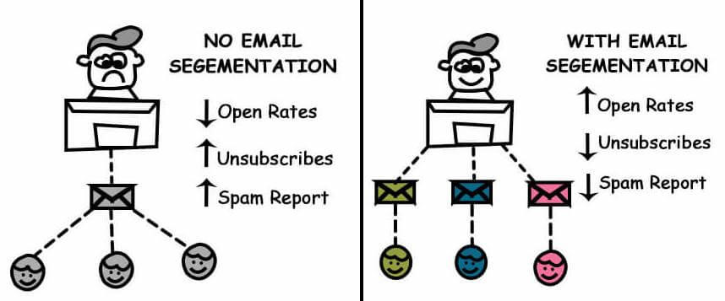

**Leverage the power of video for more shares and memorability**

**There are tons of**[**video marketing stats**](https://www.wordstream.com/blog/ws/2017/03/08/video-marketing-statistics)**that highlight the importance of this medium for growing your business, but in terms of online presence, you should know these three:**

* **Social video generates**[**1200%**](https://learn.g2crowd.com/video-marketing-statistics)**more shares than text and image content combined.**
* **Viewers retain**[**95%**](http://www.insivia.com/50-must-know-stats-about-video-marketing-2016/)**of a message when they watch it in a video compared to 10% when reading it in text.**
* **YouTube is, by far (with the exception of Facebook) the most popular online platform in the U.S.**

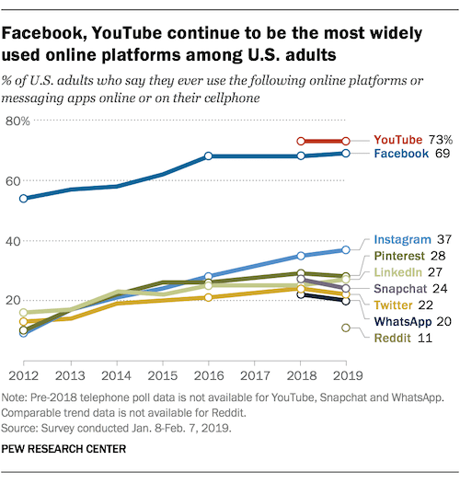

**REPORT CREATED BY**

**FAHAD IQBAL SHAH**

**PRODUCT MANAGEMENT INTERN**

**NOVO CABS**